**CHINHOYI UNIVERSITY OF TECHNOLOGY**



Real Estate Project Proposal: CUITM219

GROUP MEMBERS:

GUIDANCE MUPIKATA C23156476P

KELVIN K NKOMA C23156638M

SIMON T DZENGEZEKWA C23155686R

CHAPTER 1: INTRODUCTION

1.1 Background

The real estate industry is rapidly transforming through the integration of digital technology, reshaping the way buyers, sellers, and agents interact. Traditional processes often involve fragmented communication and inefficiencies, making property transactions tedious and less accessible. Emerging technologies such as Artificial Intelligence (AI), Augmented and Virtual Reality (AR/VR), and advanced data analytics offer the potential to address these inefficiencies. By leveraging these innovations, it is possible to create platforms that streamline property searches, enhance decision-making, and provide secure transactions.

1.2 Problem Definition

The current real estate landscape is hindered by several challenges:

* Limited access to comprehensive property information.
* Lack of personalized recommendations for buyers and renters.
* Inefficient property viewing methods that demand physical presence.
* Absence of real-time data-driven insights for market trends and property valuations.
* Insufficient security measures to safeguard user data and transactions.

Existing platforms fail to offer a cohesive solution that combines personalization, immersive experiences, analytics, and robust security, leaving stakeholders with sub-optimal tools for property transactions.

1.3 Aim

The aim of this project is to design and develop an advanced mobile and web application for the real estate industry that integrates cutting-edge technologies to simplify property transactions, enhance user experience, and ensure security and transparency for all stakeholders.

1.4 Objectives

To achieve the aim, the project sets the following objectives:

* Simplify and expedite property search and transaction processes.
* Enhance user engagement through AI-driven personalized recommendations.
* Provide immersive property exploration using AR/VR technology.
* Ensure the highest standards of security for user data and financial transactions.
* Develop a scalable and user-friendly platform accessible across devices, featuring an intuitive interface with clear navigation, responsive design for seamless use on smartphones, tablets, and desktops, and interactive elements such as virtual tours and 360-degree property views, ensuring that users of all technical skill levels can easily find and interact with property listings, communicate with agents, and complete transactions with minimal effort.

1.5 Justification

* + Developing an innovative platform is crucial in today’s competitive real estate market.
  + The platform integrates AI, AR/VR, and robust security measures to address existing gaps.
  + The mobile and web application aims to streamline property transactions and enhance user experience.
  + Features include AI-driven personalized recommendations, immersive AR/VR property tours, real-time data analytics, and stringent security measures.

Benefits for Home Seekers:

* + Personalized recommendations based on preferences.
  + Immersive virtual property tours.
  + Real-time market trends and property valuations.
  + Secure personal and financial data protection.

Benefits for Real Estate Agents:

* + Efficient property management and client communication.
  + Data-driven insights for competitive pricing and trend identification.
  + Enhanced client engagement through AI recommendations and immersive viewing.
  + Secure messaging and document sharing.

Benefits for Property Owners:

* + Maximized property exposure to a wide audience.
  + Efficient listing management and interest tracking.
  + Data-driven decision-making for pricing and market trends.
  + Secure personal and financial information during transactions.

Benefits for Investors:

* + Informed decision-making through real-time data analytics.
  + Efficient portfolio management and performance tracking.
  + Secure financial information and transaction integrity.
  + The initiative improves operational efficiency and fosters trust and transparency among buyers, sellers, and agents, redefining property transactions in the digital age.

CHAPTER 2: ANALYSIS

2.1 Analysis of the Existing System

The current real estate landscape is characterized by fragmented communication and inefficiencies, which hinder seamless property transactions. Traditional methods rely heavily on physical interactions and lack comprehensive digital integration. The existing systems often suffer from the following limitations:

* **Limited Access to Information:** Buyers and renters struggle to find comprehensive property information in one place, leading to time-consuming searches across multiple platforms.
* **Lack of Personalization:** Existing platforms do not offer personalized recommendations tailored to individual preferences, resulting in a generic user experience.
* **Inefficient Property Viewing:** Traditional property viewing methods require physical presence, which can be inconvenient and time-consuming.
* **Absence of Real-Time Data**: There is a lack of real-time data analytics for market trends and property valuations, making it difficult for stakeholders to make informed decisions.
* **Security Concerns:** Insufficient security measures expose user data and financial transactions to potential risks.

2.2 Requirements Analysis

2.2.1 Functional Requirements

The proposed system aims to address the limitations of the existing real estate platforms by integrating advanced technologies. The functional requirements include:

1. User Registration and Authentication:

* Users should be able to register and log in securely.
* Implementation of multi-factor authentication for enhanced security.

2. Property Search and Filtering:

* Users should be able to search for properties based on various criteria such as location, price, size, and amenities.
* Advanced filtering options to refine search results.

3. AI-Driven Personalized Recommendations:

* The system should provide personalized property recommendations based on user preferences and behavior.

4. AR/VR Property Tours:

* Integration of AR/VR technology to offer immersive virtual property tours.
* 360-degree views of properties for enhanced user experience.

5. Real-Time Data Analytics:

* Provision of real-time market trends and property valuations.
* Data-driven insights for competitive pricing and trend identification.

6. Secure Communication and Transactions:

* Secure messaging and document sharing between users and agents.
* Robust security measures for financial transactions.

7. Property Management:

* Efficient property listing management for agents and owners.
* Tracking of property interest and engagement.

8. User Interface and Experience:

* Intuitive and user-friendly interface with clear navigation.
* Responsive design for seamless use on smartphones, tablets, and desktops.

2.2.2 Non-Functional Requirements

The non-functional requirements ensure the system's performance, security, and usability. These include:

1. Performance:

* The system should handle a large number of concurrent users without performance degradation.
* Fast loading times for property searches and virtual tours.

2. Security:

* Implementation of robust security measures to protect user data and financial transactions.
* Compliance with data protection regulations.

3. Scalability:

* The platform should be scalable to accommodate increasing user numbers and property listings.

4. Usability:

* The system should be easy to use for users of all technical skill levels.
* Accessibility features for users with disabilities.

5. Reliability:

* The system should be reliable with minimal downtime.
* Regular backups and disaster recovery plans.

6. Compatibility:

* The platform should be compatible with various devices and operating systems.
* Support for multiple browsers and screen sizes.

2.3 Use Case Diagrams

Use case diagrams will illustrate the interactions between different users (actors) and the system. These diagrams will help visualize how users will interact with the platform to achieve their goals. Key actors include:

* **Home Seekers:** Users looking to buy or rent properties.
* **Real Estate Agents:** Professionals managing property listings and client interactions.
* **Property Owners:** Individuals or entities listing their properties for sale or rent.
* **Investors:** Users interested in real estate investments.

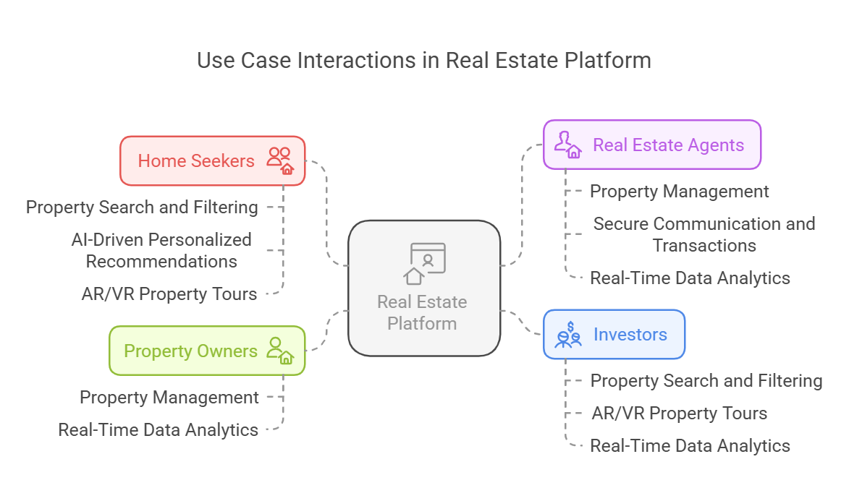

The use case diagrams will depict scenarios such as property search, virtual tours, secure transactions, and data analytics.

2.4 Risk Analysis

Potential Risks

1. Technical Risks:

* Integration challenges with AR/VR technology.
* Data security breaches.
* System performance issues under high load.

2. Operational Risks:

* Resistance to change from traditional methods.
* Inadequate user training and support.

3. Financial Risks:

* High initial development and implementation costs.
* Ongoing maintenance and update expenses.

Mitigation Strategies

1. Technical Risks:

* Conduct thorough testing and quality assurance.
* Implement robust security protocols and regular audits.
* Optimize system performance through scalable architecture.

2. Operational Risks:

* Provide comprehensive user training and support.
* Promote the benefits of the new system to encourage adoption.

3. Financial Risks:

* Develop a detailed budget and cost-benefit analysis.
* Explore funding opportunities and partnerships.

By addressing these risks proactively, the project can ensure a smooth transition to the new platform and achieve its objectives effectively.

CHAPTER 3: DESIGN

3.1 System Architecture

The proposed real estate platform will adopt a multi-tier architecture to ensure scalability, security, and performance. The architecture will consist of the following layers:

1.Presentation Layer:

* This layer includes the user interfaces for both mobile and web applications. It will be designed to be responsive and accessible across various devices.
* Technologies: HTML, CSS, JavaScript, React.js for web, and React Native for mobile.

2. Application Layer:

* This layer contains the business logic and processes user requests. It will handle tasks such as property searches, AI-driven recommendations, and AR/VR integrations.
* Technologies: Node.js, Express.js for backend services.

3. Data Layer:

* This layer manages data storage and retrieval. It will include databases for storing user information, property listings, transaction records, and analytics data.
* Technologies: PostgreSQL for relational data, MongoDB for unstructured data.

4. Security Layer:

* This layer ensures the protection of user data and financial transactions. It will implement robust security measures such as encryption, multi-factor authentication, and regular security audits.
* Technologies: OAuth 2.0, SSL/TLS, Firewalls.

5. Integration Layer:

* This layer facilitates integration with external services such as AR/VR technologies, AI engines, and data analytics tools.
* Technologies: RESTful APIs, GraphQL for data querying.

3.2 UI/UX Design

Wireframes

Wireframes will be created to outline the layout and functionality of key screens in the application. These will include:

* Home Screen: Featuring property search functionality, filters, and AI-driven recommendations.
* Property Detail Screen: Displaying detailed property information, 360-degree views, and AR/VR tour options.
* User Dashboard: Providing access to saved properties, messages, and transaction history.
* Agent/Owner Dashboard: Offering tools for property management, client communication, and analytics.

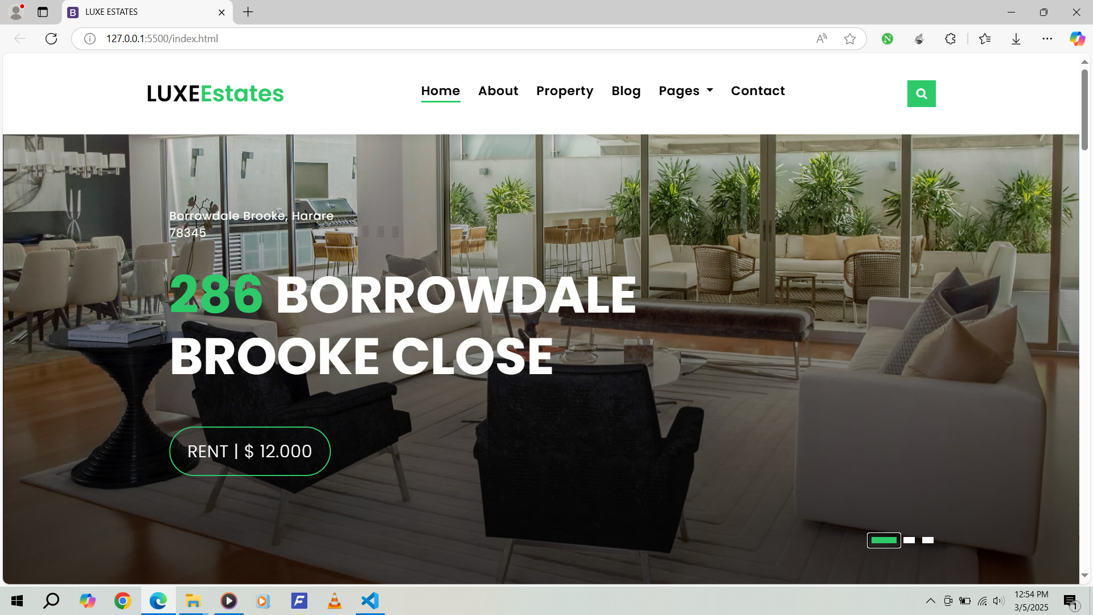

1. Home Screen

User Experience Considerations

* Intuitive Navigation: Clear and consistent navigation menus to enhance user experience.
* Accessibility: Design considerations for users with disabilities, including screen reader compatibility and keyboard navigation.
* Responsive Design: Ensuring the application is usable across smartphones, tablets, and desktops.
* Interactive Elements: Incorporating virtual tours, 360-degree property views, and real-time data visualizations.

3.3 Database Design

Database Schema

The database will be designed to efficiently store and manage various types of data. Key tables and their relationships include:

* Users Table: Stores user information, including authentication details and preferences.
* Fields: UserID (Primary Key), Name, Email, PasswordHash, Role (e.g., Home Seeker, Agent, Owner, Investor).
* Properties Table: Contains property listings with detailed information.
* Fields: PropertyID (Primary Key), Address, Price, Size, Amenities, OwnerID (Foreign Key).
* Transactions Table: Records all financial transactions within the platform.
* Fields: TransactionID (Primary Key), PropertyID (Foreign Key), BuyerID (Foreign Key), Amount, Date.
* Messages Table: Stores communication between users and agents.
* Fields: MessageID (Primary Key), SenderID (Foreign Key), ReceiverID (Foreign Key), Content, Timestamp.
* Analytics Table: Holds real-time data analytics for market trends and property valuations.
* Fields: AnalyticsID (Primary Key), PropertyID (Foreign Key), MarketTrends, Valuation, Date.

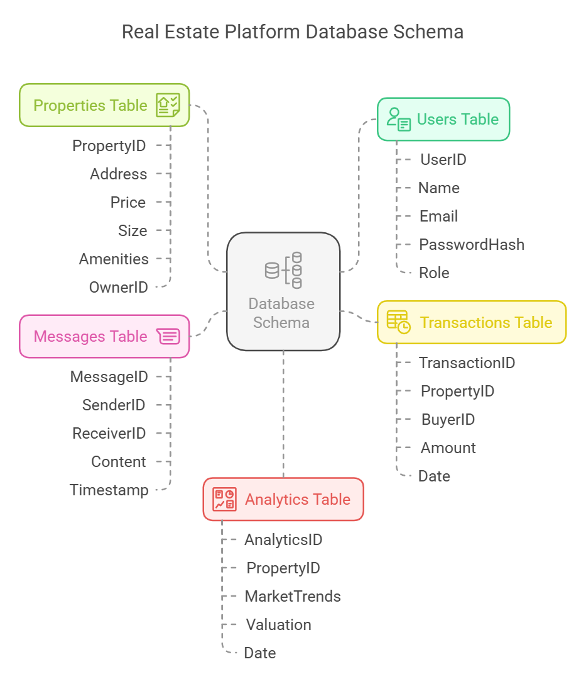

Security Measures

* Encryption: Sensitive data such as passwords and financial information will be encrypted.
* Access Control: Role-based access control to ensure users can only access data relevant to their role.
* Regular Backups: Implementing regular data backups and disaster recovery plans.

3.4 Class Diagram

A class diagram will represent the system's structure, illustrating the main classes, their attributes, methods, and relationships. Key classes include:

* User Class: Represents users of the system, with attributes such as UserID, Name, Email, and methods for registration and authentication.
* Property Class: Represents property listings, with attributes such as PropertyID, Address, Price, and methods for viewing and managing listings.
* Transaction Class: Represents financial transactions, with attributes such as TransactionID, PropertyID, BuyerID, and methods for processing payments.
* Message Class: Represents communication between users, with attributes such as MessageID, SenderID, ReceiverID, and methods for sending and receiving messages.
* Analytics Class: Represents data analytics, with attributes such as AnalyticsID, PropertyID, MarketTrends, and methods for generating insights.

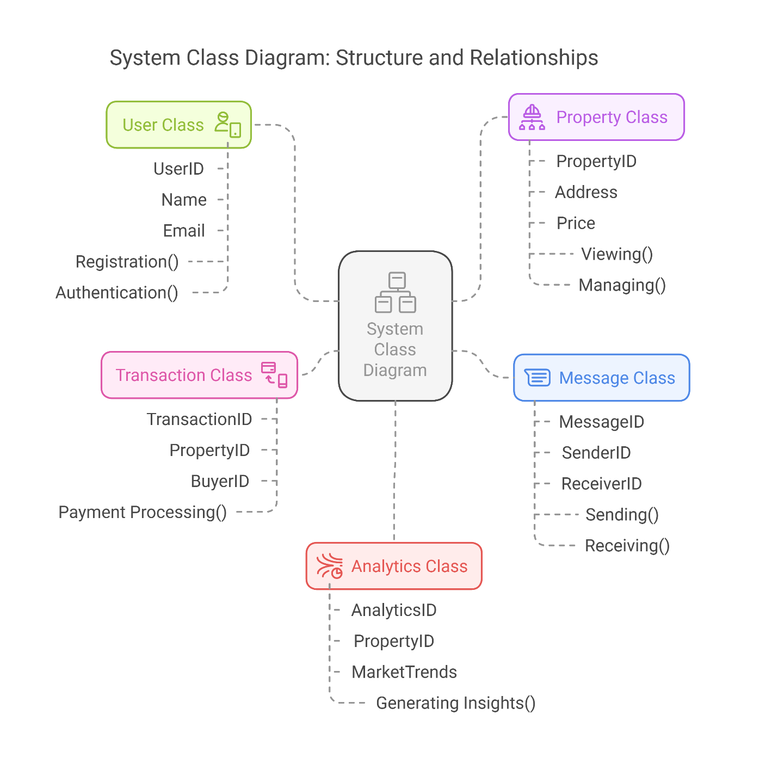

3.5 Sequence Diagrams

Sequence diagrams will illustrate interactions between system components or objects for key processes such as:

* User Registration: Showing the sequence of events from user input to database storage.
* Property Search: Depicting the flow of data from user query to search results display.
* AR/VR Tour: Illustrating the interaction between the user interface and AR/VR integration for virtual property tours.
* Secure Transaction: Demonstrating the steps involved in processing a secure financial transaction.

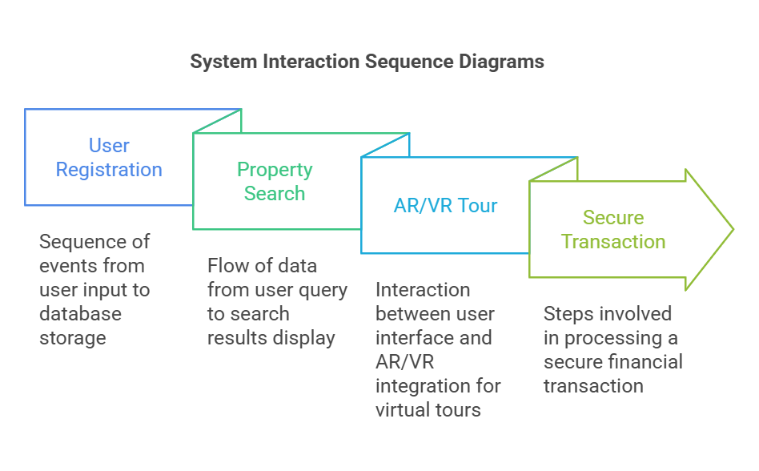

3.6 Data-Flow Diagram

Data-flow diagrams will illustrate the movement of data within the system, highlighting key processes such as:

* Data Input: User inputs for registration, property searches, and communication.
* Data Processing: AI-driven recommendations, real-time data analytics, and AR/VR integrations.
* Data Output: Display of search results, property details, and transaction confirmations.
* Data Storage: Storing user information, property listings, and transaction records in the database.

These diagrams will help visualize the flow of data and ensure that all components of the system are integrated effectively.

